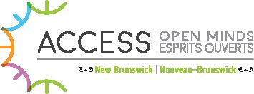

PROJECT OVERVIEW

ACCESS OPEN MINDS

ACCESS Open Minds is a research project in Canada. We look
for better ways for youth to get help with mental health. We have
two partners who support us in this work: the Graham Boeckh
Foundation and the Canadian Institute of Health Research’s
Strategy for Patient Oriented Research.
The mental health system needs change. Youth (ages 11 to 25) who live with mental health challenges should be able to:
GET CARE EARLIER GET CARE QUICKER GET BETTER CARE
CONTINUE TO GET CARE AS THEY GROW INTO YOUNG ADULTS
HAVE A VOICE IN THE KIND OF MENTAL HEALTH CARE THEY RECEIVE
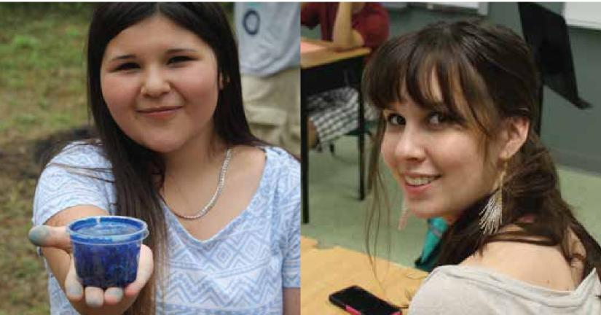

ACCESS OPEN MINDS NEW BRUNSWICK
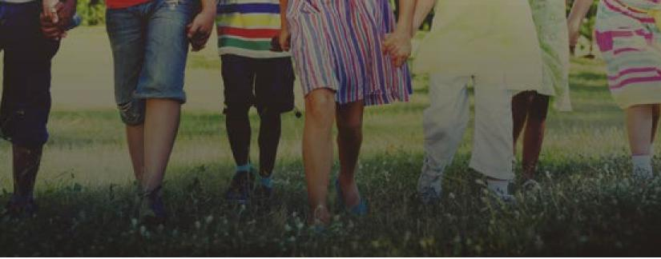
Team NB is made up of youth and their supporters,
First Nations, community, researchers, decision
makers, and service providers.
TEAM NEW BRUNSWICK (NB)
New Brunswick was chosen for this research project because it is
representative of Canada. It is bilingual, diverse, urban and rural.

NEW BRUNSWICK’S CHALLENGES
In the Children and Youth Rights and Well-being Snapshot, the New Brunswick Health Council and the Child and Youth Advocate reported that:
- In New Brunswick, the rate of youth hospitalization due to mental health issues in 2013-2014 was twice (2x) the Canadian average.
- Many NB youth report
that they are unhappy with the
mental health care they receive.
NEW BRUNSWICK’S
SOLUTION
We will work to make sure that all New Brunswick youth have timely access to community-based mental health care. We will listen and work with youth and their supporters. We will look for people and organizations that offer support to the community already. We will work with them to find out what other support is needed. Our suggestions will be tailored to each community, recognizing that each is different and unique.

ACCESS OPEN MIND NEW BRUNSWICK RESEARCH AND EVALUATION PLAN

During the project, we will collect and analyze information to see how our work makes a difference in the lives of youth in NB.

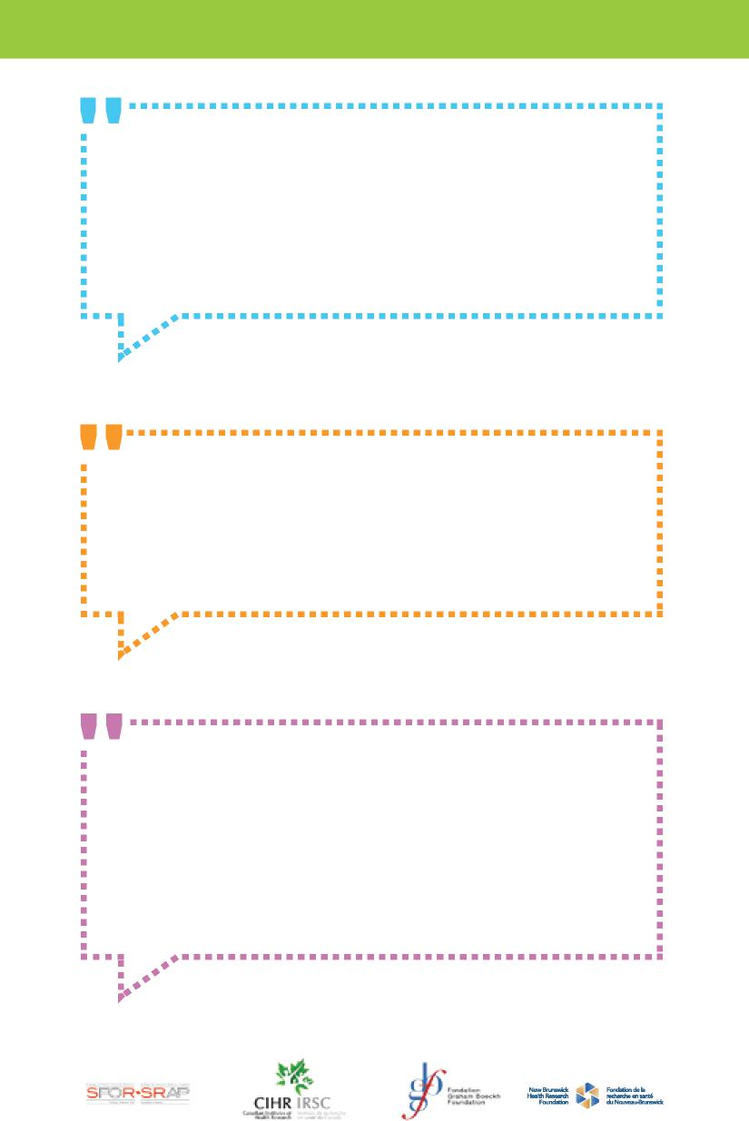
“I think safe spaces will make a huge difference in the way that youth talk about and access mental health care. Having a safe place for youth to access the services they need will mean that more people will be able to get the help they need when they need it.”
Lee, Youth Advisory Committee member
“By having family/carers a part of the planning and decision-making for this project, it is not only allowing us to share our experiences but also to work together and help youth throughout their recovery.”
Charlotte, Family Chair
“We look forward to sharing our strengths and experiences that will ultimately contribute to the provincial transformation. We believe that ACCESS Open Minds can make a big difference in the lives of First Nations youth, by respecting their cultural diversity and by ensuring that mental health services are offered in a culturally safe environment.”
Eva & Roxanne, First Nations Co-Chairs

